ABSTRACT:

With the increasing volume of sensitive data, secure and scalable storage solutions are essential. This paper presents a system combining IPFS and Hyperledger Fabric for decentralized and tamper-proof file storage and retrieval. Files are stored on IPFS, generating a unique CID, which is recorded on Hyperledger Fabric for added security. Authorized users can securely access data using private keys and the CID. This study highlights the system's potential for decentralized, secure, and efficient data management.

INTRODUCTION:

In today’s rapidly advancing technological era, the exponential growth of data has necessitated robust solutions to securely manage and store sensitive information. Mishandling or unauthorized access to this data can result in significant consequences, particularly when it involves crucial information such as legal documents, financial records, or other sensitive files. Ensuring the confidentiality and integrity of this data requires innovative storage and management solutions. Among the most secure methods is the use of private blockchains, combined with decentralized storage systems like IPFS.

Blockchain is a distributed digital ledger consisting of transaction-containing blocks. Each transaction is cryptographically signed with a private key and broadcast to network nodes for inclusion in a block. The mining process validates these transactions and incorporates the candidate block into the blockchain. Due to its immutable nature, any alteration to the data on the blockchain is impossible without invalidating the entire ledger. This makes blockchain a highly secure and reliable technology for data storage.

To complement blockchain’s immutability, InterPlanetary File System (IPFS) is used for decentralized data storage. IPFS generates unique content identifiers (CIDs) for every entity stored, ensuring universal accessibility and data integrity. IPFS allows for efficient and secure data retrieval, with content being stored across a peer-to-peer network.

For our project, we chose to integrate Hyperledger Fabric, a permissioned blockchain framework, to create and maintain a private blockchain network. Hyperledger, a project initiated by the Linux Foundation, is known for its modular architecture and emphasis on secure, token-based solutions without native cryptocurrencies. Hyperledger Fabric allows us to build a robust and tamper-resistant system for managing files with traceability, resilience, and transparency, ensuring secure access to authorized users only.

This paper explores the design and implementation of a secure file management system using Hyperledger Fabric for blockchain storage and IPFS for decentralized file storage, addressing the challenges of data security, transparency, and accessibility.

CONCLUSION:

This paper presents a document management system leveraging IPFS for decentralized file storage and a future integration with Hyperledger Fabric for secure, tamper-proof record-keeping. The system provides efficient file handling and storage, while the blockchain enhances transparency and security. Future improvements will focus on advanced AI tools for document categorization and blockchain-based features such as auditing and access control, creating a modern, scalable solution for secure file management.

SUMMARY OF THE REFERENCE PAPERS:

1.The paper "Decentralized Data Storage Solutions using Hyperledger Fabric" highlights a system where geospatial data is securely stored using IPFS for decentralized storage and Hyperledger Fabric for permissioned blockchain management. This approach aligns closely with our project, which leverages a similar combination of IPFS for distributed content-addressing and Hyperledger Fabric for secure transaction tracking. However, while the paper emphasizes geospatial data and employs tools like Convert API for format compatibility, our focus extends to general document management, ensuring seamless integration with IPFS for CID-based retrieval and blockchain storage for audit trails. Both systems highlight the strengths of combining blockchain's immutability with IPFS's decentralized storage, but ours aims to further simplify user interaction and explore broader applications like organizational document workflows and secure file-sharing mechanisms.

2.The paper “Distributed File Storage Model using IPFS and Blockchain” presents a novel approach to secure and efficient data management using Inter Planetary File System (IPFS) and blockchaintechnology. It focuses on addressing the challenges of centralized storage systems, particularly in the context of medical data, which includes sensitive information like patient details, medical records, and prescriptions. The proposed system stores encrypted medical files in IPFS, utilizing its peer-to-peer distributed architecture and content-based addressing for efficient and decentralized file storage. Blockchain is integrated to store metadata, such as file hash values and transaction IDs, ensuring the integrity, immutability, and secure access to data. Advanced cryptographic techniques, including SHA-256 for hash generation and AES symmetric encryption for file security, are employed. Patients maintain control over their data, with access granted only to authorized users like doctors or technicians through unique keys. The solution enhances data privacy, integrity, and availability while minimizing storage overhead and duplication. The distributed architecture of IPFS ensures reliability even in cases of node failures, making the system scalable, transparent, and secure for healthcare applications.

3.This paper “Land Record Management using Hyperledger Fabric and IPFS” proposes a secure and transparent system for managing land ownership records by integrating Hyperledger Fabric, a permissioned blockchain, with the InterPlanetary File System (IPFS). Traditional land record systems often face issues like tampering, fraud, and inefficiencies due to centralized and manual processes. The proposed model leverages the decentralized and immutable features of blockchain to ensure tamper-proof and transparent record-keeping, while IPFS enables secure, distributed storage of land documents. Hyperledger Fabric provides controlled access, where only authorized stakeholders, such as government officials, can update records, while landowners can view their data. Additional layers of security, including Passport middleware for user authentication, ensure that access is logged and traceable. The system also employs cryptographic techniques like hashing and asymmetric encryption for data integrity and privacy. By combining these technologies, the solution streamlines documentation, ensures transparency, reduces fraud, and provides robust legal evidence for disputes. The system's decentralized nature also enhances resilience and scalability, making it a transformative step for land record management.

The paper “Document Management System using Blockchain” proposes a blockchain-based system for secure and tamper-proof storage of digital documents, addressing issues like document duplication, theft, and centralized database vulnerabilities. The system utilizes blockchain technology for its decentralized ledger, ensuring immutable records, and InterPlanetary File System (IPFS) for efficient and secure storage of documents using content-based addressing. Documents are uploaded in formats like PDFs or images, hashed using the SHA-256 algorithm, and stored in IPFS, with their hashes recorded on the blockchain to maintain data integrity and prevent unauthorized modifications. Smart contracts automate document verification and management processes, enhancing efficiency and reducing manual intervention. The system also integrates APIs and platforms like MetaMask for secure user interactions and transaction management. By leveraging these technologies, the proposed solution ensures high data reliability, quick retrieval, reduced duplication risks, and robust document security. Future enhancements could include incorporating Natural Language Processing (NLP) for document analysis and forgery detection, further strengthening security and usability. This system aims to revolutionize document management across sectors by offering a scalable, transparent, and decentralized approach.

The paper “A Hyperledger Fabric-Based Organizational Decentralized Access Control Solution” proposes a decentralized access control and resource management solution for organizations using Hyperledger Fabric, a permissioned blockchain framework. It addresses vulnerabilities in centralized systems, such as single points of failure and security risks, by introducing a blockchain-based system that enhances transparency, security, and efficiency. The solution includes Single Sign-On (SSO) for seamless authentication across multiple applications and uses features like channels and membership service providers (MSP) to manage organizational subunits and access control policies effectively.

The proposed system ensures secure resource access by employing HRCA (Human Resource Certification Authority) to issue identity certificates and allows team managers to assign access rights to users. It leverages smart contracts to enforce access control policies and logs user activities immutably on the blockchain for auditing and security purposes. The architecture is designed for scalability, enabling the addition of peers and channels as the organization grows, and eliminates the need for energy-intensive consensus mechanisms like Proof of Work. By providing a decentralized, tamper-proof mechanism for access control and activity tracking, the solution enhances organizational resource management. Future work includes integration with third-party tools like Bitbucket and expanding the system to include vendor organizations, further improving interoperability and functionality.

This paper “Implementation of Blockchain and Peer-to-Peer Network for Digital Document Management” presents a decentralized system for managing digital documents using blockchain technology and InterPlanetary File System (IPFS) to overcome the vulnerabilities of traditional centralized systems, such as tampering and unauthorized alterations. The system uses the Ethereum blockchain to record operations like storage, retrieval, and ownership transfer while IPFS serves as a peer-to-peer network for secure document storage. Users interact with the system through a web-based interface built using React**.**js, with smart contracts implemented in Solidity to automate operations securely. Key features of the system include document hashing for data integrity, ownership validation, and seamless ownership transfer via blockchain transactions. MetaMask is used for user authentication and transaction management. Testing revealed an average upload speed of 40.61 KBps and demonstrated robust file integrity checks, where even minor file modifications resulted in unique hash values. The system efficiently handles various file types and sizes while ensuring transparency and traceability. By integrating blockchain's immutability and IPFS's decentralized storage, the solution provides a scalable, secure, and user-friendly approach to digital document management.

In recent years, various researchers have explored the integration of blockchain and decentralized storage technologies to address the limitations of traditional data management systems. Jadhav et al. [1] demonstrated a robust combination of Hyperledger Fabric and IPFS for managing geospatial data. Their work highlights the advantages of blockchain’s immutability and IPFS’s decentralized storage capabilities. While their focus is domain-specific, primarily targeting geospatial applications, our project builds on similar principles, adapting them to general document management scenarios.

Similarly, Lazar et al. [2] introduced a model tailored for medical data, employing IPFS for encrypted storage and blockchain for metadata integrity. This solution ensures the security and privacy of sensitive medical records, which aligns with our emphasis on combining IPFS and blockchain. However, we aim to broaden the scope to cater to a wider range of documents, enabling seamless and secure workflows across diverse domains.

The work by Patil et al. [3] applied Hyperledger Fabric and IPFS to improve land record management. Their system ensures transparency and tamper-proof documentation in property transactions, addressing challenges in centralized land record systems. While their focus lies in secure land management, our approach generalizes the application of blockchain and IPFS to offer similar transparency and efficiency for organizational document workflows.

Pokharkar et al. [4] presented a document management system using IPFS and blockchain to enhance data integrity and retrieval efficiency. Their work integrates smart contracts for automating document verification. Our system builds on this foundation by further simplifying user interaction and exploring features like secure file-sharing and organizational document processes.

Patil et al. [5] proposed a decentralized access control mechanism using Hyperledger Fabric, designed to address security gaps in centralized systems. By leveraging smart contracts for activity logging and access management, they demonstrated the potential of blockchain in organizational resource control. Inspired by this, our project adopts a similar strategy to manage document storage and retrieval securely, while prioritizing user-friendly design.

Finally, V. Patil et al. [6] developed a blockchain-based system that combines Ethereum and IPFS for digital document management. While their focus was on ensuring file integrity and secure operations, our work extends these concepts by adopting Hyperledger Fabric for enhanced control and privacy. This choice aligns better with enterprise requirements, ensuring secure and permissioned access to sensitive data.

These studies collectively highlight the transformative potential of integrating blockchain and decentralized storage. Our work seeks to unify these advancements while addressing gaps in usability, scalability, and versatility for document management systems.

RESULTS AND DISCUSSIONS:

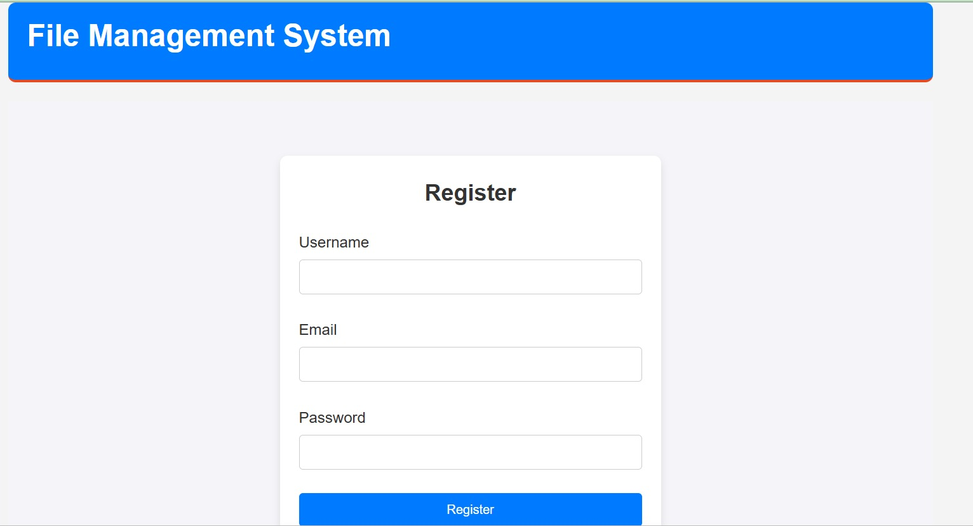

Figure 1. New user registration

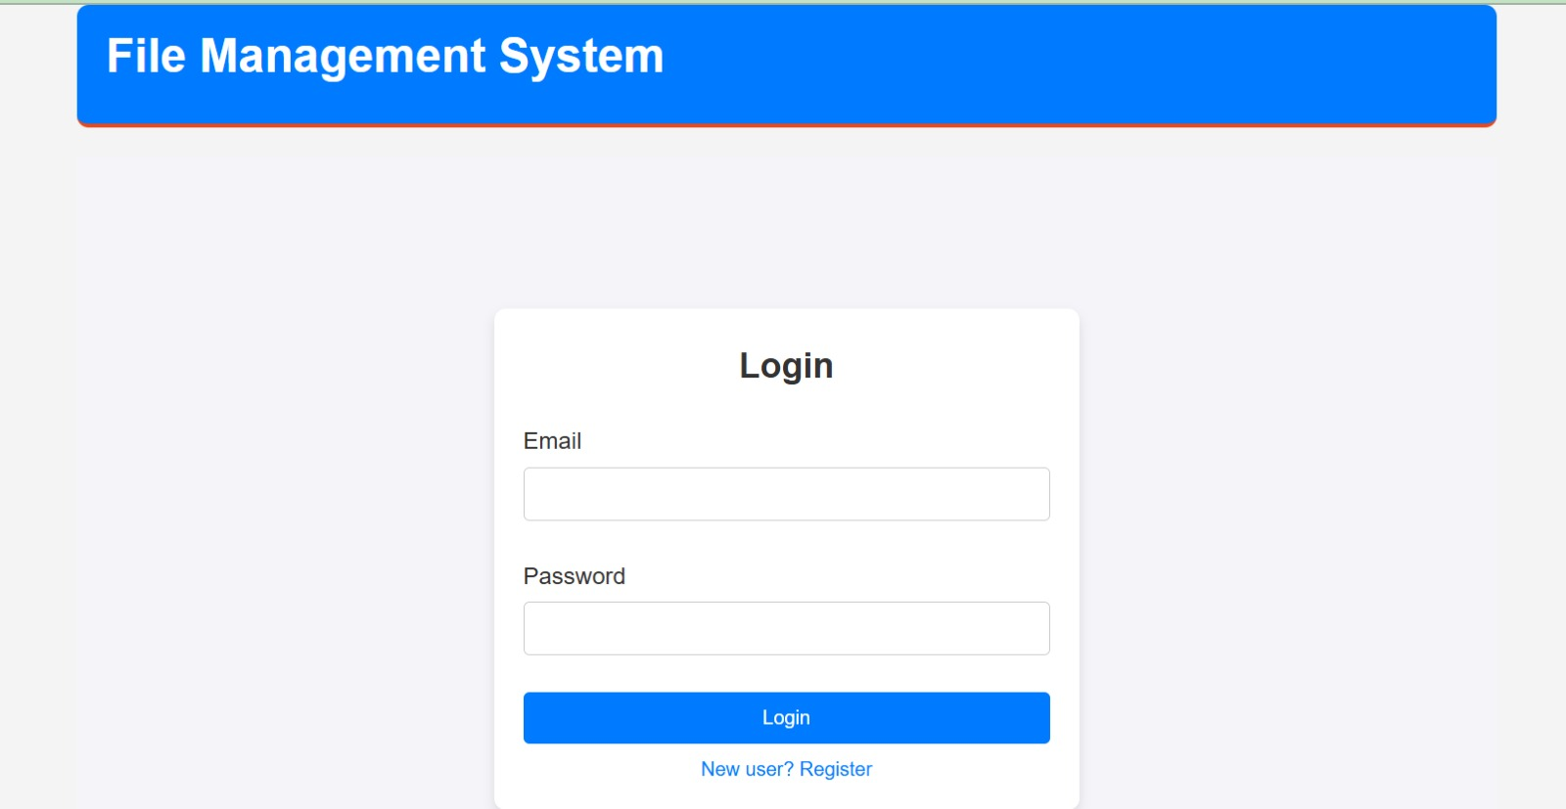

Figure 2: Login page for Admin and User access

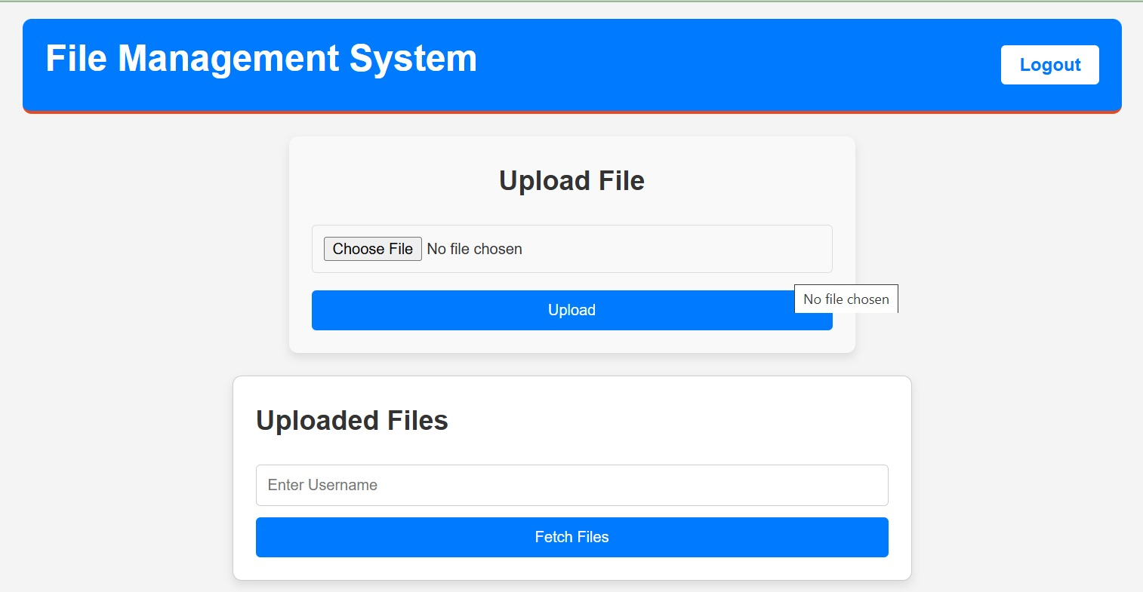

Figure 3: Upload file and Fetch files based on permissions

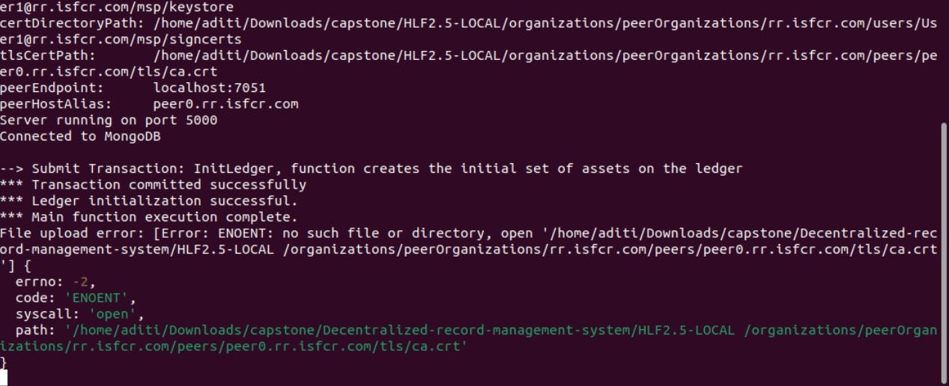

Figure 4: Ledger is committed after successful upload

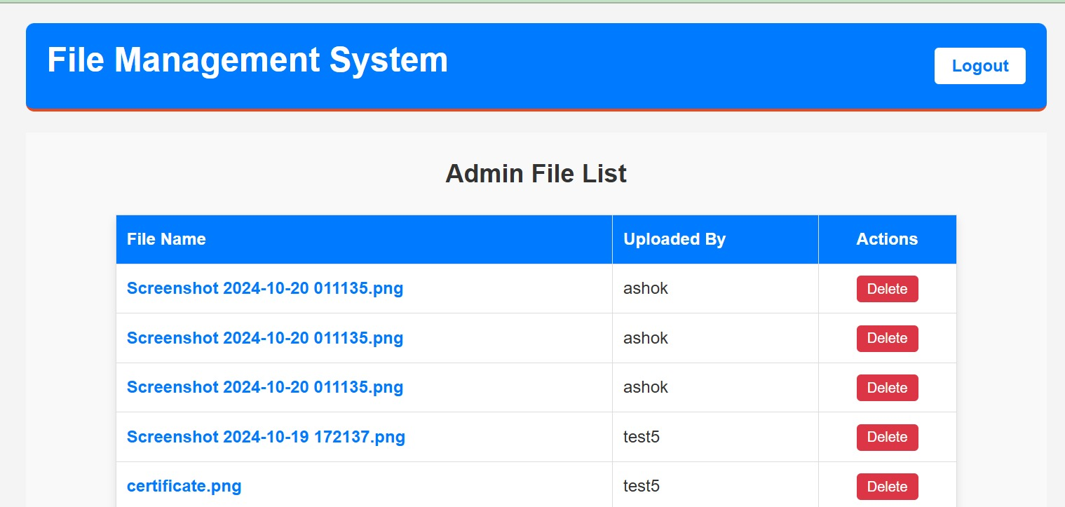

Figure 5: Admin Page

In this study, the document management system was successfully implemented using IPFS for decentralized file storage and Hyperledger Fabric for blockchain-based metadata storage. The system ensures secure, immutable, and traceable file management, with files encrypted before being stored on IPFS. The integration with Hyperledger Fabric guarantees that transaction details are securely logged, enabling accountability and tamper-proof records.

The figures illustrate the successful development of the website application, incorporating user authentication, role-based access control with distinct views based on permissions, and the implementation of a tamper-resistant network for secure and decentralized file management.